KANTIPUR ENGINEERING COLLEGE
(Affiliated to Tribhuvan University)
Dhapakhel, lalitpur


CE755
A FINAL YEAR PROJECT ON
“SIGNAL OPTIMIZATION AT SATDOBATO INTERSECTION”
SUPERVISOR
Er. Reeta Khadka

SUBMITTED BY:
Aabishkar Kafle (KAN077BCE001)
Ahilya Yadav (KAN077BCE006)
Anil Deshar (KAN077BCE011)
Chandan Sah (KAN077BCE021)
Dinesh Singh Samant (KAN077BCE023)
Kamal Pokhrel (KAN077BCE033)

DEPARTMENT OF CIVIL ENGINEERING
DHAPAKHEL, LALITPUR
MARCH, 2025

DECLARATION

We hereby declare that this study entitled “Signal Optimization At Satdobato Intersection” is based on our original research work. Related works on the topic by other researchers have been duly acknowledged. We owe all the liabilities relating to the accuracy, authenticity and any other information included hereunder.

Aabishkar Kafle (KAN077BCE001)
Ahilya Yadav (KAN077BCE006)
Anil Deshar (KAN077BCE011)
Chandan Sah (KAN077BCE021)
Dinesh Singh Samant (KAN077BCE023)
Kamal Pokhrel (KAN077BCE033)

COPYRIGHT
The author has agreed that the library, Department of Civil Engineering, Kantipur Engineering College may make this freely available for inspection. Moreover, the author has agreed that permission for extensive copying or use of the materials of the project works for scholarly purpose may be granted by the supervisor of the project work recorded herein or, in their absence, by the Head of the Department of Civil Engineering, Kantipur Engineering College. Copying or publication or the other use of the thesis for financial gain without approval of the Department of Civil Engineering, Kantipur Engineering College and author’s written permission to copy or to make any other use of the material in this thesis in whole or in part should be addressed to:

………………………..
Head of Department
Department of Civil Engineering
Kantipur Engineering College
Dhapakhel, Lalitpur

CERTIFICATE
The undersigned recommend to the Institute of Engineering for the acceptance of a project entitled, “SIGNAL OPTIMIZATION AT SATDOBATO INTERSECTION” submitted by Aabishkar Kafle, Ahilya Yadav, Anil Deshar, Chandan Sah, Dinesh Singh Samant and Kamal Pokhrel in partial fulfilment for Bachelor degree in Civil Engineering.

…………………. …….………………………..
Er. Reeta Khadka Er. Shesh Raj Kafle
(Project Supervisor) (External Examiner)

ACKNOWLEDGEMENT

We are indebted to express our deepest and heartiest gratitude to those who have put their effort and enthusiasm, time and endeavor for making us able to succeed in writing this research paper. We, hereby, would like to take this opportunity to express our heartfelt gratitude towards Kantipur Engineering College, Dhapakhel.
We would like to express our deepest gratitude to our research supervisor, Er.Reeta Khadka, for her continuous guidance, support and encouragement throughout our research work.
We would also like to convey our sincere thanks to Er. Sudeep Thapa, HOD, Department of Civil Engineering, Kantipur Engineering College, Er. Hemant Tiwari, Er. Reeta Khadka, and the civil department for providing us time, effort, and support and helping us to improve our presentation skills with proper suggestions.
We extend our heartfelt appreciation to the Nepal Police Headquarters, Naxal, for granting us access to crucial CCTV footage through an official letter. We are also deeply thankful to the Traffic Office at Ranipokhari for their assistance in providing CCTV footage and thankful to Metropolitan police for their coordination during field work.
Last but not the least, we would like to thank everyone who has helped us during our research, directly or indirectly.
Thank you.
Aabishkar Kafle (KAN077BCE001)
Ahilya Yadav (KAN077BCE006)
Anil Deshar (KAN077BCE011)
Chandan Sah (KAN077BCE021)
Dinesh Singh Samant (KAN077BCE023)
Kamal Pokhrel (KAN077BCE033)

ABSTRACT

This report provides an overview on traffic condition of Satdobato intersection and it's approaches for accessing the location. This intersection connects the major commercial and residential hubs of Lalitpur district and thus has a very heavy traffic flow Control Delay and LOS are calculated as performance measures of Satdobato Intersection to show the prevailing condition. The environment and traffic flow parameters are modeled in a microsimulation software ‘SIDRA Intersection 8.0’. Optimization of the signal timing is performed by changing the cycle lengths and splitting the timing. Further, the continuous left-turning movement is controlled under signal time. The traffic activity included the traffic volume of 7am to 7pm for three weekdays and peak flow period was used for analysis.
The total control delay of each leg and direction of flow was taken as the input for the analysis of level of service. Finally, the LOS of each leg and direction of flow was obtained. Our result shows that the Control Dealy is lesser in the Evening for SE and SW, whereas, Control Delay for NE and NW is lesser in the morning than in the evening.

Keywords: Intersection, LOS, Signal Timing
Table of Contents
1. Introduction 1
1.1 Background 1
1.2 Rationale of the Study 2
1.3 Objective 3
1.3.1 Specific Objectives: 3
1.4 Scope 3
1.5 Limitation of the Study 4
1.5.1 Data Availability and Accuracy: 4
1.5.2 Assumptions in Traffic Modeling: 4
1.5.3 Limited Scope of Study Area: 4
1.5.4 Exclusion of Pedestrian and Non-Motorized Traffic: 4
1.5.5 Infrastructure Constraints: 4
1.5.6 External Factors: 5
1.5.7 Traffic Control Device Limitations: 5
1.5.8 Simulations and Real-World Variability: 5
1.5.9 Time Constraints: 5
1.5.10 SIDRA Limitations: 5
1.5.11 Lack of Advanced Simulation 5
2. Literature Review 6
2.1 Introduction 6
2.2 Design Software 7
2.2.1 Key Features: 8
2.3 Terminology: 9
2.4 Traffic Flow Characteristics: 12
2.4.1 Diverging and merging: 13
2.4.2 Crossing and weaving: 13
2.4.3 Design capacity and level of services: 13
2.5 Lane Grouping 15
2.6 Estimation of Delay 16
3.Methodology 19
3.1 Flow chart 19
3.2 Study Area 20
3.3 Primary & Secondary Data Collection 20
3.4 Data Extraction 21
3.5 Data Analysis and Presentation 21
3.5.1 Traffic & Pedestrian Volume 21
3.5.2 Geometric Data 26
3.5.3 Input Parameters 27
3.5.4 Existing Phase and Signal Timing 27
3.5.5 Classified Vehicle Count & PCU 29
3.5.6 LOS 29
4. Output Analysis 30
4.1 System Changes and Result Comparison 30
4.1.1 Optimum Cycle Allocation (Change l) 30
4.1.1.1 Optimized Existing Phase Timing (MORNING) 30
4.1.1.2 Design Phase Timing (Morning) 32
4.1.2 Comparison of Existing Phase and Design Phase (Morning) 34
4.1.3 Optimized Existing Phase Timing (EVENING) 34
4.1.3.1 Design Phase Timing (Evening) 36
4.1.4 Comparison of Existing phase and Design Phase (Evening) 39
4.2 Left Turn Controlled Movement with Optimum Cycle (Change ll) 39
4.2.1 Design Phase Left Turn Controlled (Morning) 40
4.2.2 Comparison of Design Phase and LC Design Phase (Morning) 42
4.3 Design Phase Left Turn Controlled (Evening) 42
4.4 Comparison of Design Phase and LC Design Phase (Evening) 45
5. Conclusion and Recommendation 46
5.1 Conclusion 46
5.2 Recommendation 46
6. References 47
APPENDIX 49

List of Tables
Table 1: Existing Signal Timing (Morning)
Table 2: Existing Signal Timing (Evening)
Table 3: Passenger Car Unit (Nepal standard Road 2070)
Table 4: LOS Criteria for Signalized Intersection (HCM 2010)
Table 5: Optimized Existing Phase Timing (Morning)
Table 6: Existing Control Delay (Morning)
Table 7: Design Phase Timing (Morning)
Table 8: Design Phase Control Delay (Morning)
Table 9: Comparison of Existing and Design Phase (Morning)
Table 10: Optimized Existing Phase Timing (Evening)
Table 11: Existing Phase Control Delay (Evening)
Table 12: Design Phase Timing (Evening)
Table 13: Design Phase Control Delay (Evening)
Table 14: Comparison of Existing and Design Phase (Evening)
Table 15: Design Phase LC Timing (Morning)
Table 16: Design Phase LC control Delay (Morning)
Table 17: Comparison of Design Phase and LC Design Phase (Morning)
Table 18: Design Phase LC Timing (Evening)
Table 19: Design Phase LC Control Delay (Evening)
Table 20: Comparison of Design Phase and LC Design Phase (Evening)

List of figures:

Figure 1: Types of Traffic Conflicts
Figure 2: Typical Lane group for analysis
Figure 3: Signalized intersection delay model
Figure 4: Satdobato Intersection
Figure 5: Vehicle Distribution GW-HB (Morning)
Figure 6: Vehicle Distribution MK-LG (Morning)
Figure 7: Vehicle Distribution HB-MK (Morning)
Figure 8: Vehicle Distribution LG-GW (Morning)
Figure 9: Vehicle Distribution GW-HB (Evening)
Figure 10: Vehicle Distribution MK-LG (Evening)
Figure 11: Vehicle Distribution HB-MK (Evening)
Figure 12: Vehicle Distribution LG-GW (Evening)
Figure 13: Site Layout
Figure 14: Existing Phase Sequence
Figure 15: Existing Phase (Morning)
Figure 16: Existing Phase Control Delay (Morning)
Figure 17: Design Phase (Morning)
Figure 18: Design Phase Control Delay (Morning)
Figure 19: Existing Phase (Evening)
Figure 20: Existing Phase Control Delay (Evening)
Figure 21: Design Phase (Evening)
Figure 22: Design Phase control Delay (Evening)
Figure 23: Design Phase LC (Morning)
Figure 24: Design Phase LC Control Delay (Morning)
Figure 25: Design Phase LC (Evening)
Figure 26: Design Phase LC Control Delay (Evening)

Acronyms and Abbreviations
ADB Asian Development Bank
CCTV Closed Circuit Television
DOTM Department of Transport Management
HCM Highway Capacity Manual
JICA Japan International Cooperation Agency
KSUTP Katmandu Sustainable Urban Transport Project
LOS Level of Service
LT Left Turn
LC Left Controlled
MOF Ministry of Finance
NE North East
NW North West
RT Right Turn
PCU Passenger Car Unit
SE South East
SIDRA Signalized Intersection Design and Research Aid
SW South West

1. Introduction

1.1 Background
Traffic congestion is a growing challenge in rapidly urbanizing cities, leading to delays, fuel wastage, and environmental pollution. Kathmandu, the capital of Nepal, is one of the most crowded cities in the world. Its rapid growth is mainly due to government policies that focus on jobs, education, healthcare, and sports. These opportunities attract people from different parts of the country, making Kathmandu a major center for those seeking a better life.
However, the increasing population and migration have caused serious traffic congestion. The rise in private vehicle ownership, supported by technological advancements, has worsened the problem. By 2021/22, Nepal had over 5 million registered vehicles (MoF, 2022), with 36% of them in the Bagmati zone (DoTM, 2018). This high concentration makes traffic management and road safety more difficult. Studies show that traffic congestion leads to annual losses of NRs 16.5 billion due to wasted time and fuel (Bista & Paneru, 2021; ADB, 2019).
Several road expansion and upgrading projects are currently in progress to improve traffic flow in the Kathmandu Valley. In an effort to manage congestion at intersections, traffic signals have been installed at many locations over the past few years. However, these signals are often not optimized to adapt to real-time traffic conditions, leading to frequent manual operation by traffic police, particularly during peak hours.
To address these challenges, national authorities, with support from international organizations, have implemented various projects focused on intersection improvement and traffic signalization. Significant initiatives include the Kathmandu Sustainable Urban Transport Project (KSUTP) (ADB, 2012) and the Data Collection Survey on Traffic Improvement in Kathmandu Valley (JICA, 2012). Given the ongoing traffic issues, there is an urgent need for a structured approach to assess intersection performance and explore different signal configurations to enhance overall traffic conditions.
To address this issue, this study focuses on developing a methodology for assessing intersections in the Kathmandu Valley by analyzing different signalization configurations to enhance traffic performance. The effectiveness of this approach has been evaluated through case studies conducted at Satdobato intersection.
The Satdobato intersection is a four-legged signalized intersection located in Lalitpur, a major city within the Kathmandu Valley. It serves as a key connection point for vehicles traveling to and from Patan, Gwarko, Balkumari, and Ring Road. With heavy traffic flow throughout the day, the intersection frequently experiences:
- Long vehicle queues and delays
- Poor Level of Service (LOS) due to unoptimized signal phasing
- Conflicts between vehicles, pedestrians, and public transport
- Inefficient left-turn and U-turn movements causing bottlenecks
A significant factor influencing traffic at the Satdobato intersection is the newly constructed Gwarko Overpass. While the flyover aims to improve mobility at Gwarko, it has also altered traffic patterns, leading to increased vehicle inflow toward Satdobato. The redistribution of traffic demand has further strained the intersection, making it essential to design an efficient signal system and evaluate its Level of Service (LOS).
Intersection models in SIDRA software were developed to evaluate the performance of these intersections in their existing conditions
In Nepal, traffic management has traditionally relied on manual control and static signal timings, which often fail to adapt to real-time traffic variations. This research aims to assess the existing performance of the Satdobato intersection, identify key traffic inefficiencies, and propose optimization strategies to enhance overall efficiency. By implementing advanced traffic management techniques, this study will contribute to the improvement of urban mobility, commuter convenience, and environmental sustainability in Kathmandu Valley. The intersection models, with some adjustments, were also utilized to assess the expected performance of the intersections under the ongoing geometric improvements.

1.2 Rationale of the Study
The Satdobato intersection in Lalitpur, Nepal, is a crucial traffic junction that experiences significant congestion, delays, and inefficiencies due to increasing vehicular movement and unoptimized signal timings. Given its strategic importance in Kathmandu Valley’s Road network, improving traffic flow at this intersection is essential for enhancing overall urban mobility. The need to conduct this study are:
a. Growing Traffic Congestion:
Rapid urbanization and increasing vehicle ownership in Kathmandu Valley have led to frequent traffic jams at key intersections like Satdobato. Inefficient traffic management and outdated signal designs contribute to longer delays and reduced Level of Service (LOS).
b. Need for Data-Driven Traffic Solutions:
Traditional traffic management methods often rely on manual control and rough estimations, which may not be sufficient for modern, high-density traffic scenarios. This study employs microsimulation tools like SIDRA Intersection to assess current intersection performance and propose scientifically backed improvements.
c. Optimization of Signal Timings and Intersection Design:
Adjusting cycle lengths, split times, and lane allocations can significantly improve intersection performance. The study aims to identify the most effective traffic control measures, including continuous left-turn movements and optimized signal phasing, to enhance overall efficiency.
d. Contribution to Urban Planning and Policy Making:
Findings from this study will provide valuable insights for traffic engineers, urban planners, and policymakers. The recommendations can help design better intersection management strategies not only for Satdobato but also for similar high-traffic urban areas in Nepal.

By addressing these key issues, this research aims to contribute to sustainable urban mobility, reduce congestion-related fuel consumption, and improve commuter experiences in Kathmandu Valley.

1.3 Objective
The main objective of the study is to evaluate the performance of the Satdobato intersection.

1.3.1 Specific Objectives:

• Quantification of the current traffic flow scenario in the Intersection.
• Comparison of the performance of the intersection with the existing signal timing with optimized signal timing using SIDRA software.

1.4 Scope
The study focuses on evaluating the current traffic signal performance and determining the Level of Service (LOS) at the four-legged Satdobato intersection in Lalitpur, Nepal. Key activities include collecting traffic volume data, analyzing signal timing and measuring vehicle delays. The analysis will be conducted using microsimulation software SIDRA Intersection 8.0, to model traffic flow and identify potential improvements. The goal is to provide recommendations for optimizing signal timings and enhancing intersection performance to alleviate congestion.
It includes:
a. Traffic Flow Analysis:
Collecting and analyzing traffic volume data for different time periods (peak and off-peak hours).
Understanding the traffic composition (e.g., vehicles, pedestrians, etc) and patterns at the intersection.
b. Existing Signal Evaluation:
Reviewing the current signal design and timing strategies.
Assessing how well the current signal system manages traffic flow and congestion.
c. LOS Estimation:
Estimating the existing Level of Service (LOS) at the intersection based on traffic volume, delay, and congestion and evaluating the performance of the intersection under different traffic conditions.

d. Signal Optimization:
Testing different signal configurations (e.g., signal timing, coordination, phasing) using simulation software like SIDRA to find the most efficient signal design.

1.5 Limitation of the Study

1.5.1 Data Availability and Accuracy:
- The quality and availability of traffic data for the Satdobato intersection may be limited or not entirely accurate, which can affect the reliability of the LOS estimation and signal optimization.
- Traffic counts, vehicle classification, or peak hour data might not be sufficiently detailed or may come from outdated sources.

1.5.2 Assumptions in Traffic Modeling:
- The assumptions made regarding vehicle types, traffic flow patterns, or arrival rates could limit the accuracy of the optimization models.
- Traffic behavior under different weather conditions, special events, or unexpected traffic surges might not be fully considered.

1.5.3 Limited Scope of Study Area:
- The study focuses on a specific intersection (Satdobato), and the findings may not be fully applicable to other intersections with different characteristics (e.g., larger intersections or those in different geographic areas).
- The study may not consider the effects of adjacent intersections, which could influence the traffic flow and signal optimization.

1.5.4 Exclusion of Pedestrian and Non-Motorized Traffic:
- Pedestrian traffic and non-motorized users (e.g., cyclists) may not be adequately incorporated into the signal optimization model, leading to an incomplete evaluation of the intersection's overall service quality.
- The interaction between motorized and non-motorized traffic could affect LOS and optimization but might be outside the scope of this study.

1.5.5 Infrastructure Constraints:
- The design of the intersection, including the road geometry, number of lanes, and available space, could constrain the signal optimization process, limiting the effectiveness of the proposed solution.
- Physical limitations of the intersection or budgetary constraints might affect the proposed signal implementation.

1.5.6 External Factors:
- The impact of external factors, such as economic changes, population growth, or urban development in the Satdobato area, might not be fully incorporated into the study's predictions.
- Environmental factors (such as air quality or noise pollution due to idling vehicles) may not be part of the analysis but could play a role in real-world intersection performance.

1.5.7 Traffic Control Device Limitations:
- The limitations of the traffic control devices (signal controllers) and their ability to adjust to real-time traffic demands (adaptive signal control systems) may restrict the optimization.
- The interaction between signal phases and vehicle detection technology could affect the accuracy of signal phase timing recommendations.

1.5.8 Simulations and Real-World Variability:
- The traffic simulation tools used in the study may not perfectly reflect real-world conditions, and the results of these simulations could vary under different traffic scenarios or during abnormal conditions.
- The effect of human factors, such as driver behavior, road familiarity, and compliance with traffic signals, may not be adequately captured in the study.

1.5.9 Time Constraints:
- The project timeline may not have allowed for extensive field observations or data collection, limiting the ability to fully validate the signal optimization and LOS determination results.
- Real-time monitoring and adjustments during the study period might not have been feasible.
1.5.10 SIDRA Limitations:
SIDRA focuses on static, fixed-cycle signal optimization and does not fully model dynamic traffic conditions, which may limit the accuracy of the LOS estimation under fluctuating traffic patterns.
1.5.11 Lack of Advanced Simulation:
More advanced tools like VISSIM and AIMSUN, which offer detailed microsimulation and dynamic signal control, were not used due to time and resource constraints, limiting the depth of traffic behavior analysis.

2. Literature Review

2.1 Introduction

The Highway Capacity Manual (HCM) serves as a foundational resource, providing a standardized methodology for evaluating intersection performance. It defines key parameters such as level of service (LOS), capacity, saturation flow, and delay, which are widely used metrics in traffic analysis. Capacity, a critical measure, is defined as the maximum number of vehicles that can reasonably pass through an intersection during a given period under prevailing roadway, environmental, and traffic conditions. Researchers like Webster and Cobbe explored methods for directly estimating intersection saturation flow from approach width, providing a practical approach for initial assessments. However, the complexities of mixed traffic conditions necessitate further refinements. Anusha et al. addressed this by proposing adjustment factors specifically designed for mixed traffic scenarios, recognizing the varying impacts of different vehicle types on traffic flow. Ning Wu contributed by developing two distinct models for capacity estimation in signalized intersections, offering alternative analytical approaches. In the context of Kathmandu's heterogeneous traffic, Sambridhhi and Anil investigated suitable Passenger Car Unit (PCU) values for various vehicle categories and developed delay estimation models tailored to these unique conditions. Their work emphasized the importance of accurately representing the diverse vehicle mix in traffic analysis. Furthermore, Mahapatra et al. highlighted the influence of mixed traffic, lane indiscipline, and the increased maneuverability of certain vehicles on saturation flow, suggesting that these factors can actually lead to an increase in saturation flow under specific circumstances.
While analytical models, like those presented in the HCM, offer a relatively quick and straightforward method for evaluating intersection performance, particularly for determining if a facility is operating near or exceeding capacity, they may have limitations when it comes to capturing the nuances of real-world traffic behavior and evaluating system-wide impacts. Simulation models, on the other hand, offer a more detailed and dynamic approach. They can model the behavior of individual vehicles, interactions between vehicles, and the complex dynamics of traffic flow under various conditions. Chaudhry et al. demonstrated the application of microsimulation by analyzing a signalized intersection in Auckland. Their calibrated model, incorporating realistic local parameters, yielded results comparable to those obtained from analytical approaches, particularly in unsaturated conditions, validating the use of microsimulation for representing real-world traffic scenarios. Ranjitkar et al. utilized SIDRA software to evaluate the operational efficiency of different intersection types (priority-controlled, roundabout, and signalized) based on average delay, total emissions, and capacity. Their research provided insights into the relative strengths and weaknesses of each intersection type under varying traffic volumes and turning ratios, demonstrating the value of using simulation tools for comparative analysis. Akçelik and Besley further explored the relationship between theoretical analytical methods and microsimulation methods, contributing to a better understanding of the strengths and limitations of each approach.
Tianzi et al. conducted a comparative study of SIDRA and VISSIM for signalized intersection analysis, suggesting that SIDRA offers advantages in terms of simpler operation and network construction, while acknowledging the capabilities of both software packages for evaluating the impacts of traffic control measures. Their work emphasized the importance of these tools for data-backed decision-making in urban traffic management.
Beyond comparing different software packages, researchers have also focused on refining simulation methodologies. Mathew and Radhakrishnan proposed a comprehensive framework for microsimulation of traffic, encompassing mixed traffic representation, identification of sensitive parameters, assignment of parameter ranges, and the development of optimization models. Ekman et al. highlighted the importance of calibration by comparing results obtained using default input settings in SIDRA with those obtained using manually edited, site-specific data. Their findings underscored the benefits of calibration for improved model accuracy. Mathew et al. further contributed by performing a sensitivity analysis of model parameters, which can significantly reduce the effort required for model optimization. Practical guidelines and manuals, such as the Traffic Modeling Guidelines and the Signal Timing Manual, offer valuable guidance for practitioners. The Traffic Modeling Guidelines suggest using saturation flow as a key calibration parameter and queue length as a validation parameter. The Signal Timing Manual emphasizes that oversaturation cannot be fully resolved by signal timing optimization alone and suggests the implementation of queue management strategies. Huang et al. identified three key phenomena associated with oversaturation: storage bay blocking, residual queuing, and spillback, emphasizing the need for appropriate traffic management strategies tailored to specific saturation regimes. Xuan et al. investigated the impact of lane assignment on intersection performance, demonstrating that dedicated left-turn lanes can sometimes reduce approach capacity. Finally, Ahd et al. modeled three different intersections, demonstrating the potential for significant performance improvements through infrastructure modifications such as lane additions and overpasses.
Dhakal et al. (2023) used SIDRA intersection software for evaluation and performance enhancement of signalized intersection at Jay Nepal Intersection and Pokhrel et al. (2023) also performed evaluation and performance enhancement of signalized intersection for the four-legged Intersection at Satdobato, Nepal. Tiwari et al. (2023) utilized SIDRA Intersection analysis to explore the potential for signal coordination in addition to the signal optimizing at the intersections Kanti Children’s Hospital and Shital Niwas in Kathmandu. The study showed significant improvement in traffic congestion by coordinating the intersections. Also, Tiwari et al. (2023) utilized SIDRA Intersection for Evaluation and Performance Enhancement of four- Legged Intersection: Satdobato, Nepal. The analysis revealed that intersection was operating at Level of Service (LOS) F, indicating significant congestion. Similarly, Bajracharya and Dhungel (2023) performed similar study in Keshar Mahal and Durbarmarg intersection to find the beneficial results of signal coordination.

2.2 Design Software

The SIDRA software is a micro-analytical tool for evaluation of intersection performance. The SIDRA software can be used as an aid for design and evaluation of signalized intersections, roundabouts, stop control, and give-way control, and signalized pedestrian crossings.
SIDRA Intersection 8.0 is an advance software tool used for the analysis and design of intersections and networks. It's designed to aid traffic engineers and planners in evaluating and optimizing the performance of intersections, including signalized intersections and roundabouts. The software helps in predicting traffic flow, delays, and other performance measures.

2.2.1 Key Features:

  - Detailed Modeling:
    - SIDRA Intersection allows for detailed modeling of various vehicle types (cars, trucks, buses, etc.) and their behavior.
    - It can handle complex intersection geometries and traffic signal phasing.
  - Roundabout Analysis:
    - It's particularly known for its robust roundabout analysis capabilities, employing advanced gap-acceptance models.
    - it can handle single-lane and multi-lane roundabouts.
  - Signalized Intersection Analysis:
    - It also provides very detailed analysis of signalized intersections.
  - Movement Classes:
    - It allows for the modelling of seperate movement classes.
  - HCM Compliance:
    - It supports various Highway Capacity Manual (HCM) methodologies.

2.3 Terminology:

- Analysis period: A single time period during which a capacity analysis is performed on a transportation facility. If the demand exceeds capacity during an analysis period, consecutivę analysis periods can be selected to account for initial queue from the previous analysis period. Also referred to as time interval.

- Approach: A set of lanes at an intersection that accommodates all left turn, through, and right turn movements from a given direction.

- Capacity: The maximum sustainable flow rate at which vehicles or person reasonably can be expected to traverse a point or uniform segment of a lane or roadway during a specified time period under given roadway, geometric traffic, environmental, and control conditions; usually expressed as vehicles per hour, passenger cars per hour, or persons per hour.

- Clearance time: The time loss at a transit stops not including passenger dwell time. This parameter can be the minimum time between one transit vehicle leaving a stop and the following vehicle entering and can include any delay waiting for a sufficient gap in traffic to allow the transit vehicle to reenter the travel lane.

- Clearance lost time: The time, in seconds, between signal phases during which an intersection is not used by any critical movements.

- Delay: The additional travel time experienced by a driver, passenger, or pedestrian.

- Control Delay: The component of delay that results when a control signal causes a lane group to reduce speed or stop; it is measured by comparison with the uncontrolled condition.

- Critical lane group: The lane groups that have the highest flow ratio for a given signa phase.

- Critical volume-to-capacity ratio: The proportion of available intersection capacity used by vehicles in critical lane group.

- Demand: The number of users desiring service on the highway system, usually expressed as vehicles per hour or passenger cars per hour.

- Flow ratio: The ratio of the actual flow rate to the saturation flow rate for a lane group at an intersection.

- Headway: The time, in seconds, between two successive vehicles as they pass a point on the roadway, measured from the same common feature of both vehicles (for example, the front axle or the front bumper).

- Flow rate: The equivalent hourly rate at which vehicles, bicycles, or persons pass a point on a lane, roadway, or other traffic way; computed as the number of vehicles, bicycles, or persons passing the point, divided by the time interval (usually less than 1 h) in which they pass; expressed as vehicles, bicycles, or persons per hour.

- Lane distribution: A parameter used when two or more lanes are available for traffic in a single direction, and the volume distribution varies widely, depending on traffic regulation, traffic composition, speed and volume, the number of and location of access points, the origin-destination patterns of drivers, the development environment, and local driver habits.

- Lane group: A set of lanes established at an intersection approach for separate capacity and level of service analysis.

- Lane utilization: The distribution of vehicles among lanes when two or more lanes are available for a movement; however, as demand approaches capacity, uniform lane utilization develops.

- Lane width: The arithmetic mean of the lane widths of a roadway in one direction, expressed in meters.

- Peak hour factor: The hourly volume during the maximum-volume hour of the day divided by the peak 15-min flow rate within the peak hour; a measure of traffic demand fluctuation within the peak hour.

- Queue: A line of vehicles, bicycles, or persons waiting to be served by the system in which the flow rate from the front of the queue determines the average speed within the queue. Slowly moving vehicles or people joining the rear of the queue are usually considered part of the queue. The internal queue dynamics can involve starts and stops. A faster moving line of vehicles is often referred to as a moving queue or a platoon.

- Passenger Car Unit (PCU): A Passenger Car Unit (PCU) is a method used in Transport Modeling to allow for the different vehicle types within a traffic flow group to be assessed in a consistent manner. Typical factors are 1 for a car or light goods vehicle, 3 for a bus of heavy goods vehicle and 0.5 for a motorcycle.

- Intersection: Intersection is an area shared by two or more roads. This area is designated for the vehicles to turn to different directions to reach their desired destinations. Its main function is to guide vehicles to their respective directions,

- Cycle: A signal cycle is one complete rotation through all of the indications provided.

- Cycle Length: Cycle length is the time in seconds that it takes a signal to complete one full cycle of indication.

- Interval: It indicates the change from one stage to another. There are two types intervals.

- Change interval: it is also called the yellow time indicates the interval between the green and red signal indications for an approach.

- Clearance Interval: it is also called all red, included after each yellow interval indicating a period during which all signal faces show red and is used for clearing off the vehicles in the intersection.

- Green time: The duration, in seconds, of the green indication for a given movement at a signalized intersection.

- Red time: The period, expressed in seconds, in the signal cycle during which, for a given phase or lane group, the signal is red.

- Effective green time: The time during which a given traffic movement or set of movements may proceed; it is equal to the cycle length minus the effective red time

- Effective red time: The time during which a given traffic movement or set of movements is directed to stop, it is equal to the cycle length minus the effective green time.

- Phase: A phase is the green interval plus the change and clearance intervals that follow it. Thus, during green interval, non-conflicting movements are assigned into each phase It allows a set of movements to flow and safety halt the flow before the phase of another set of movements' starts.

- Loss time: It indicates the time during which the intersection is not effectively utilized for any movement.

- Saturation flow rate: It is a well-known property of traffic signals that when the light turns green on an approach graining right of way, the flow across the stop line quickly rises to a steady value, the saturation flow of the approach. The flow is often found to remain at this value until either the queue of vehicles waiting to pass through the signal is exhausted or the lights change to amber, whichever comes sonner. In the latter case, observation at the wide range of sites have shown that vehicles are willing to make use of the amber period, and the flow across the stop line falls steadily to zero during this period.

2.4 Traffic Flow Characteristics:

Traffic stream generally has flow and counter flow along a common route, unless the stream is separated into pair of one-way flows by proper design and regulations. The basic traffic maneuvers are diverging, merging, and crossing and weaving.

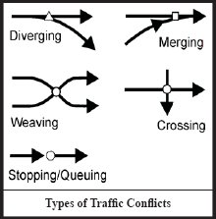
Figure 1: Types of Traffic Conflicts

2.4.1 Diverging and merging:

Of all these, diverging on the left is the easiest movement causing least problem of the traffic conflicts. This is because the traffic is regulated on the left side. Merging from the left side also does not cause much of conflicts and hazard to the traffic moving in the straight path. Transfer of a vehicle from one traffic lane to next adjacent traffic lane is called lane change and this involves diverging and merging.

2.4.2 Crossing and weaving:

The crossing traffic is the greatest problem in case of road intersections at level, because vehicles on one road have to stop while allowing the crossing stream of vehicles to cross their path. Thus, the traffic capacity of two crossroads practically reduces to that of any crossing roads or even lesser, at the intersection.
When a vehicle moves obliquely across the path of another vehicle moving in the same direction, at relatively small angle of crossing, the action is termed as weaving. The weaving maneuvers may also be considered to consist of merging and diverging operations, along the stretch.

2.4.3 Design capacity and level of services:

The capacity flow or the maximum possible flow on a roadway or a traffic lane is attained at particular optimum speed, the flow decreases at higher as well as lower speed values. Capacity flow is reached when all the vehicles flow as a stream at this optimum speed with no opportunity for overtaking, at this speed this level of service is considered to be fairly low when the volume of the road reaches the capacity or the volume to capacity ratio approaches a maximum possible value of 1.
Factors to be considered for the evaluation of LOS of a roadway in a comprehensive manner include the operating speed, travel time, traffic interruptions, freedom of maneuver, driving comfort, safety, economy etc. However, in order to simplify the level of service concept, two factors considered by the Highway Capacity Manual (HCM) are:
- the ratio of service volume to capacity and
- the operating or travel speed

The HCM has suggested six levels of Services A, B, C, D, E, F.

LOS: The average control delay per vehicle is estimated for each lane group and aggregated for each approach and for the intersection as a whole. LOS is directly related to the control delay value.

LOS A: It describes operations with a control delay of 10 s/veh or less and a volume-to-capacity ratio no greater than 1.0. This level is typically assigned when the volume-to-capacity ratio is low and either progression is exceptionally favorable or the cycle length is very short. If itis due to favorable progression, most vehicles arrive during the green indication and travel through the intersection without stopping.

LOS B: It describes operations with control delay between 10 and 20 s/veh and a volume-to-capacity ratio no greater than 1.0. This level is typically assigned when the volume-to-capacity ratio is low and either progression is highly favorable or the cycle length is short. More vehicles stop than with LOS A

LOS C: It describes operations with control delay between 20 and 35 s/veh and a volume-to-capacity ratio no greater than 1.0. This level is typically assigned when progression is favorable or the cycle length is moderate. The number of vehicles stopping is significant, although many vehicles still pass through the intersection without stopping.

LOS D: It describes operations with control delay between 35 and 55 s/veh and a volume-to-capacity ratio no greater than 1.0. This level is typically assigned when the volume-to-capacity ratio is high and either progression is ineffective or the cycle length is long. Many vehicles stop and individual cycle failures are noticeable.

LOS E: It describes operations with control delay between 55 and 80 s/veh and a volume-to-capacity ratio no greater than 1.0. This level is typically assigned when the volume-to-capacity ratio is high, progression is unfavorable, and the cycle length is long. Individual cycle failures are frequent.

LOS F: It describes operations with control delay exceeding 80 s/yeh or a volume-to-capacity ratio greater than 1.0. This level is typically assigned when the volume-to-capacity ratio is very high, progression is very poor, and the cycle length is long. Most cycles fail to clear the queue.

A lane group can incur a delay less than 80 s/veh when the volume-to capacity ratio exceeds 1.0. This condition typically occurs when the cycle length is short, the signal progression is favorable, or both. As a result, both the delay and volume-to-capacity ratio are considered when lane group LOS is established. A ratio of 1.0 or more indicates that cycle capacity is fully utilized and represents failure from a capacity perspective (just as delay in excess of 80 s/veh represents failure from a delay perspective).

2.5 Lane Grouping

The methodology for signalized intersections is disaggregate, that is, it is designed to consider individual intersection approaches and individual lane groups within approaches. Segmenting the intersection into lane groups is relatively simple process that considers both the geometry of the intersection and the distribution of traffic movements. In general, the smallest number of lane groups are used that adequately describes the operation of the intersection. The following guidelines may be applied.
An exclusive left turn lane or lanes should normally be designed as a separate lane group unless there is also a shared left through lane present, in which case the proper lane grouping will depend on the distribution of traffic volume between the movements. The same is true of an exclusive right turn lane. On approaches with exclusive left-turn or right turn lanes, or both all other lanes on the approaches would generally be included in a single lane group.
When an approach with more than one lane includes a lane that may be used by both left turning vehicles and through vehicles, it is necessary to determine whether equilibrium conditions exists or whether there are so many left turns that the lane essentially acts as an exclusive left-turn lane, which is referred to as a de facto-left turn lane.
De facto left-turn lanes cannot be identified effectively until the proportion of left turns in the shared lane has been computed if the computed proportion of left turns in the shared lane equals 1.0 (i.e., 100 percent), the shared lane must be considered a de facto left-turn lane.
When two or more lanes are included in a lane group for analysis purposes, all subsequent computations treat these lanes as a single entity. Figure 2 shows some common lane group sets for analysis.

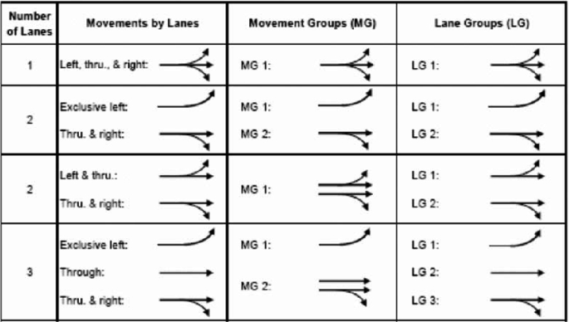
Figure 2: Typical lane group for analysis

2.6 Estimation of Delay

Average delay incurred by vehicles at signalized intersections is commonly used as a measure of intersection performance in both design and evaluation procedures. It reflects well the inconvenience caused by traffic signals to the road users and can even be converted to monetary value. However, the precise definition of delay and its measurement are not so simple.

Types of Delay:
The most common measure of operational quality is delay, although queue length is often used as a secondary measure. While it is possible to measure delay in the field, it is a difficult process, and different observers may make judgments that could yield different results. For many purposes, it is, therefore, convenient to have a predictive model for the estimate of delay. Delay, however, can be quantified in many different ways. The most frequently used forms of delay are defined as follows:

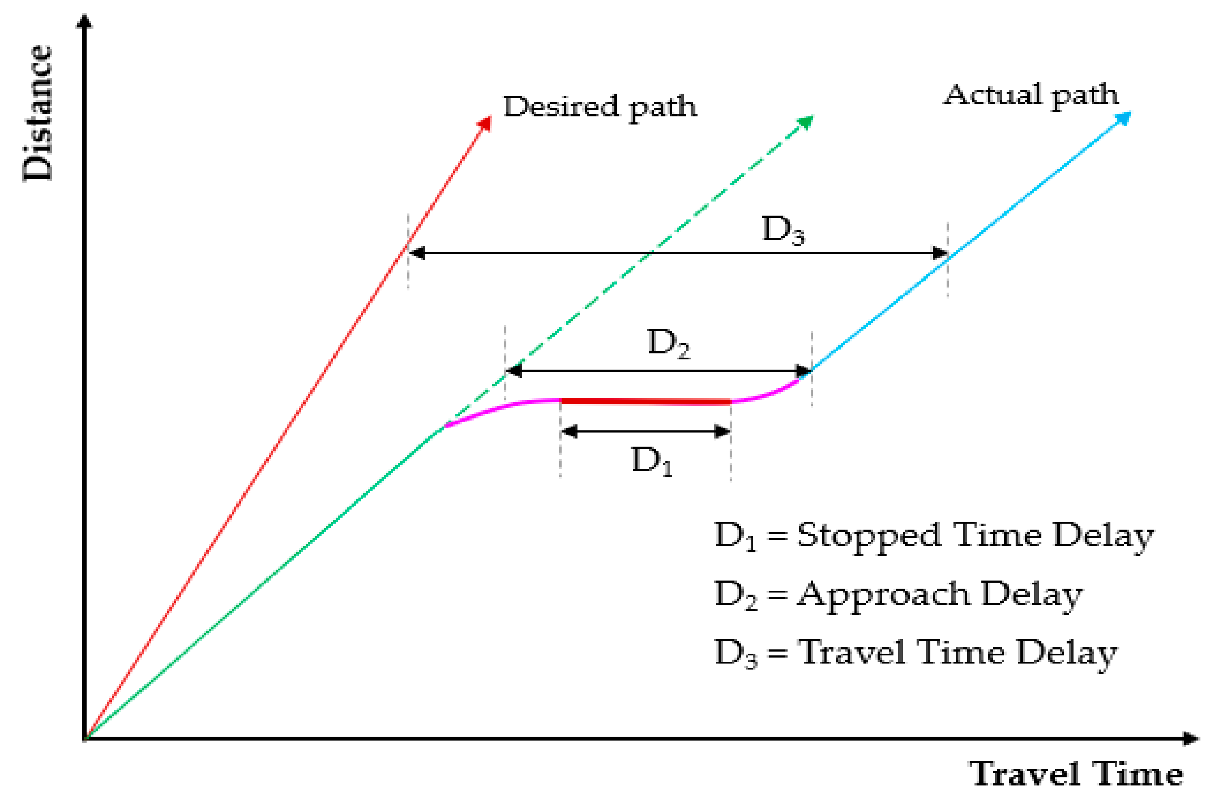
Source: https://images.app.goo.gl/dCbvs1m1dcwMqbGi8
Figure 3: Signalized intersection delay model

- Stopped time delay

Stopped-time delay is defined as the time a vehicle is stopped in queue while waiting to pass through the intersection. It begins when the vehicle is fully stopped and ends when the vehicle begins to accelerate. Average stopped-time delay is the average for all vehicles during a specified time period

- Approach Delay

Approach delay includes stopped-time delay but adds the time loss due to deceleration from the approach speed to a stop and the time loss due to reacceleration back to the desired speed. Approach Delay Approach delay includes stopped-time delay but adds the time loss due to deceleration from the approach speed to a stop and the time loss due to re-acceleration back to the desired speed.

- Travel Time Delay:

It is the difference between the drivers expected travel time through the intersection (or any roadway segment) and the actual time taken. To find the desired travel time to traverse an intersection is very difficult. So, this delay concept is rarely used except in some planning studies.

- Tune-in-queue Delay

Time-in-queue delay is the total time from a vehicle joining an intersection queue to its discharge across the STOP line on departure Average time in-queue delay is the average for all vehicles during a specified time period Time in queue delay cannot be effectively shown using one vehicle, as it involves joining and departing a queue of several vehicles

- Control Delay

Control delay is the delay caused by a control device, either a traffic signal or a STOP-sign. It is approximately equal to time-in-queue delay plus the acceleration-deceleration delay component Delay measures can be stated for a single vehicle, as an average for all vehicles over a specified time period, or as an aggregate total value for all vehicles over a specified time period. Aggregate delay is measured in total vehicle-seconds, vehicle-minutes, a vehicle-hours for all vehicles in the specified time interval Average individual delay generally stated in terms of seconds per vehicle for a specified time interval.

3.Methodology

3.1 Flow chart

Site Selection

Data Collection

Determine Input Parameters

Setup Signal Control Strategy

Conclusion and Recommendation

Signal Timing Optimization

Simulation and Analysis

Define Signal Phases
Input Network Setup
Input Data
Traffic Volume
Intersection Characteristics
Traffic Timing

Intersection Geometry
Model Setup in SIDRA

3.2 Study Area

Satdobato intersection situated on the ring road is one of the busiest and important intersections located in Kathmandu valley. This intersection is situated in Lalitpur Metropolitan City, Nepal. Its geographical location is Latitude: 27º39'19.48" Longitude: 85º19'28.9704"
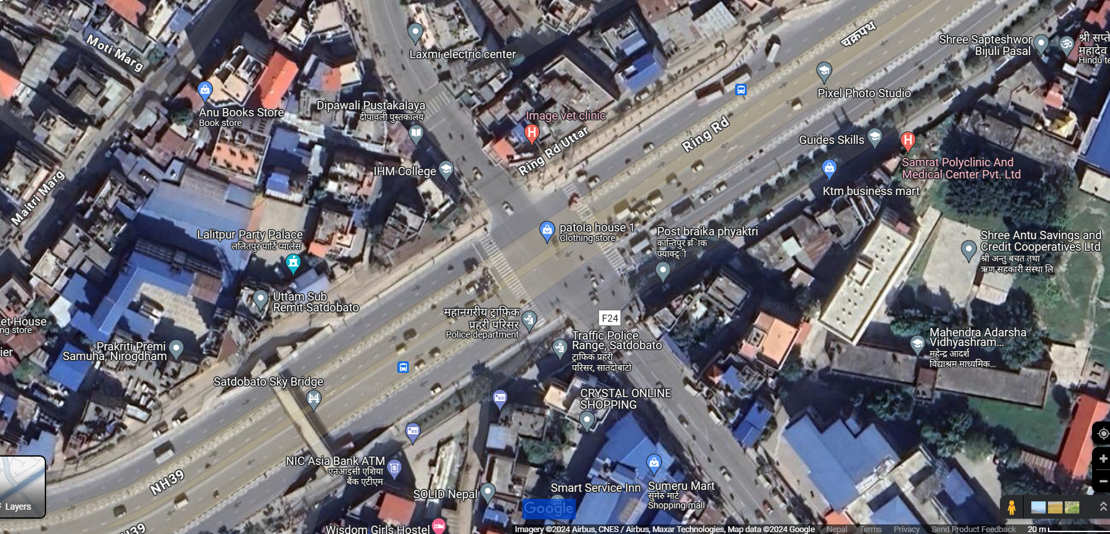
Figure 4: Satdobato Intersection (Google Map)
This intersection is considered as one of the most important intersection located in ring road. It connects the central business district of Lalitpur to densely populated areas of Lalitpur such as Jawlakhel, Hattiban and Patan. Due to this, traffic volume is increased over the years and congestion is becoming a major concern to stake-holders. Sumeru and Patan hospital is also located nearby this area which shows that emergency patients might have to be transported through this intersection.

3.3 Primary & Secondary Data Collection

For the flow analysis of the intersection, we have to collect various possible data. It might be video footage, measuring width of lane, existing road, footpath, pedestrian count, etc. which is our primary data. We also need the information about the condition of the intersection, past data, traffic police and pedestrian experience at that intersection will be our secondary data.

3.4 Data Extraction

Vehicle counts are conducted throughout the daylight hours (7 AM to 7 PM) over three days, while pedestrian counts focus on peak morning and evening periods (7 AM to 10 AM and 4 PM to 7 PM). Traffic distribution of each direction and left turn and right turn proportion is calculated.
For the standardization of the flow of vehicle standard passenger car unit (PCU) is introduced. Geometric data is collected from field by using tape. Peak hour flow ranges from Morning 8:00 A.M to 11:00 A.M and Evening 4:00 P.M to 7:00 P.M is evaluated and further analysis of control delay and LOS is done using SIDRA 8.0. Width of each lane, footpath, is taken precisely.

3.5 Data Analysis and Presentation

3.5.1 Traffic & Pedestrian Volume

The intersection traffic study, conducted on 23rd, 24th, and 25th June 2024, recorded 12 vehicle directions, 4 pedestrian directions, and 12 vehicle types. Motorcycles, accounting for about 75% of total vehicles, were the most dominant vehicle type, while tempos represented less than 3% and were the least dominant vehicle type in the intersections.
Pedestrian volumes were extracted for the respective peak hours of the following three days: 23rd, 24th and 25th of June,2024. At the Satdobato intersection, the pedestrian volumes were 821, 753, 1502 and 1549 pedestrians per three hour for the Mahalaxmisthan, Lagankhel, Gwarko, and Hattiban legs, respectively at AM. Similarly, for PM the pedestrian volumes were 975, 563, 1506 and 2085 pedestrians per three hour for the Mahalaxmisthan, Lagankhel, Gwarko, and Hattiban legs, respectively at AM.

Figure 5: Vehicle Distribution (GW-HB)

Figure 6: Vehicle distribution (MK-LG)

Figure 7: Vehicle Distribution (HB-MK)

Figure 8: Vehicle Distribution (LG-GW)

Figure 9: Vehicle Distribution (GW-HB)

Figure 10: Vehicle Distribution (MK-LG)

Figure 11: Vehicle Distribution (HB-MK)

Figure 12: Vehicle Distribution (LG-GW)

3.5.2 Geometric Data

The intersection's Gwarko and Mahalaxmisthan leg features a total width of 32.88 meters, comprising eight lanes, each 3.75 meters wide, along with two strip islands of 1.44 meters each. In contrast, the Hattiban leg is configured with four narrower lanes, each 3.50 meters wide, resulting in a total intersection width of 14 meters. Similarly, the Lagankhel leg consists of three lanes, each maintaining a width of 3.75 meters, which collectively span 11.25 meters across the intersection. This variation in lane dimensions and configurations accommodates differing traffic demands and spatial constraints across the intersection’s segments.
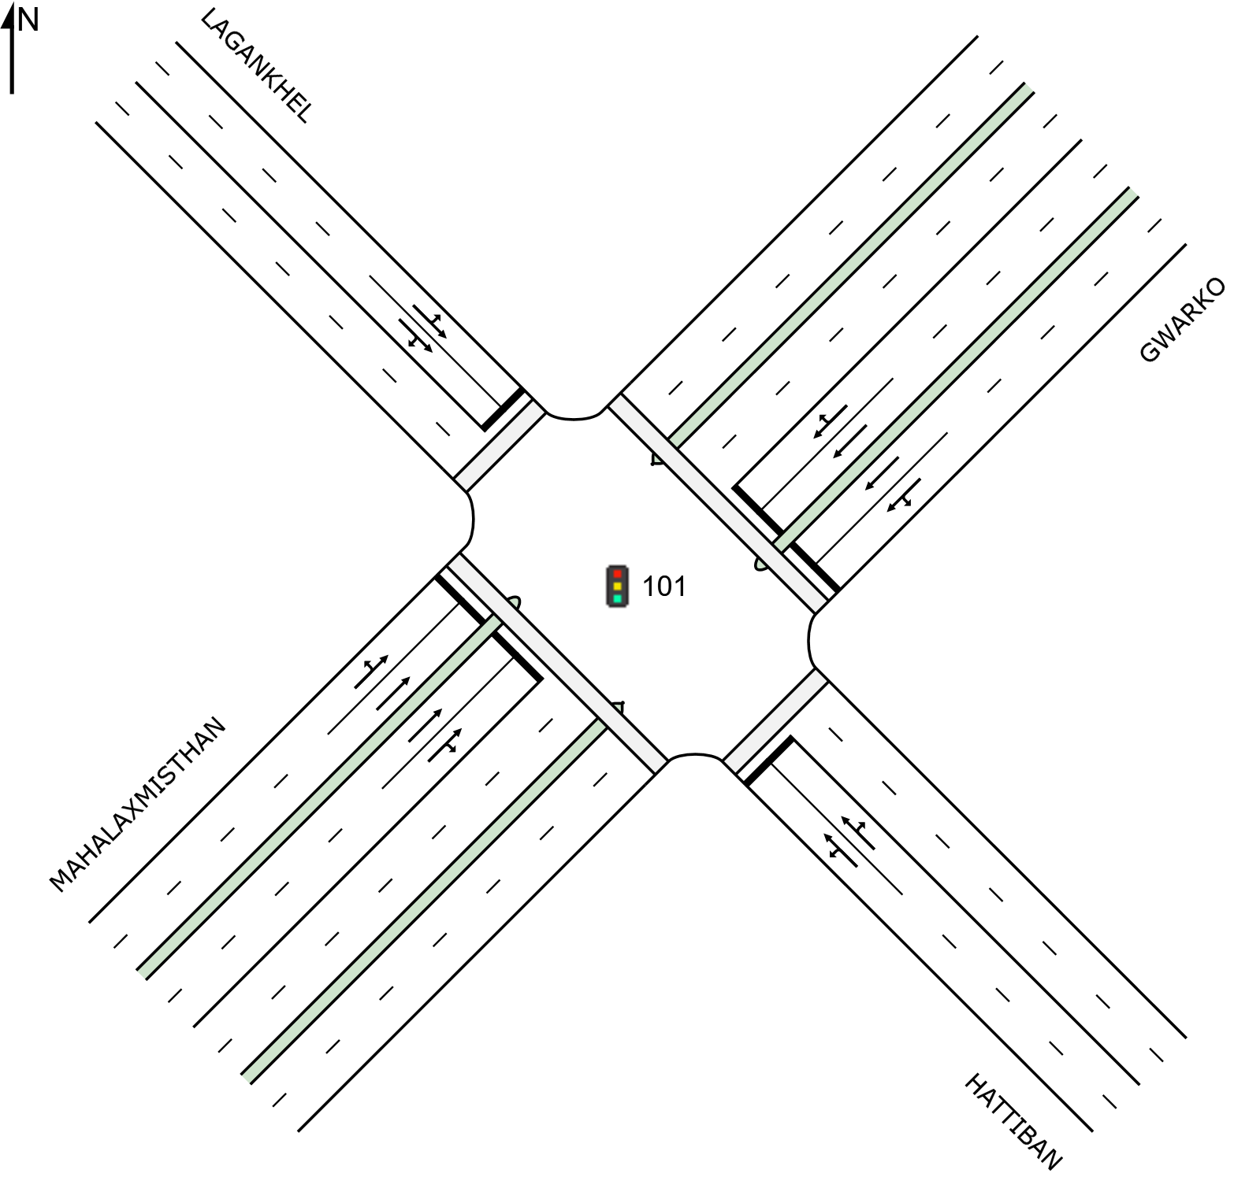

Figure 13: Site Layout

3.5.3 Input Parameters

The intersection comprises four legs Gwarko, Hattiban, Mahalaxmisthan, and Lagankhel—with the following input parameters established for analysis. All legs share a uniform approach distance of 46 meters and a basic saturation flow rate of 1,950 passenger car units per hour (tcu/h). Pedestrian characteristics include a walking speed of 1.3 meters per second and an annual growth rate of 2%, reflecting anticipated increases in foot traffic. Approach and exit cruise speeds vary across legs: Gwarko operates at 45.3 km/h, Hattiban at 47.12 km/h, (Tiwari et.al), aligning with their respective traffic flow demands and geometric configurations. These parameters collectively ensure a balanced evaluation of vehicular efficiency, pedestrian safety, and future capacity planning for the intersection’s multimodal dynamics.

3.5.4 Existing Phase and Signal Timing

PHASE TIMING SUMMARY

Phase | A | B | C | D
Phase Change Time (sec) | 0 | 118 | 214 | 292
Green Time (sec) | 112 | 90 | 72 | 62
Phase Time (sec) | 118 | 96 | 78 | 68
Phase Split | 33% | 27% | 22% | 19%

Table 1: Existing Signal Timing (Morning)

Phase | A | B | C | D
Phase Change Time (sec) | 0 | 78 | 190 | 263
Green Time (sec) | 72 | 106 | 67 | 87
Phase Time (sec) | 78 | 112 | 73 | 93
Phase Split | 22% | 31% | 21% | 26%

Table 2: Existing Signal Timing (Evening)

PHASE SEQUENCE
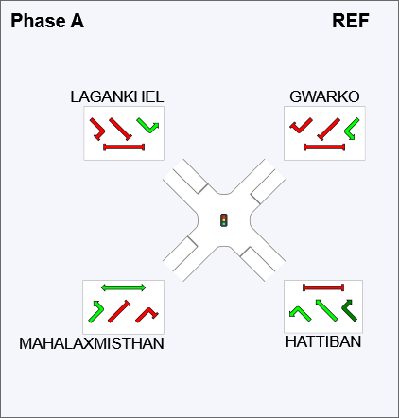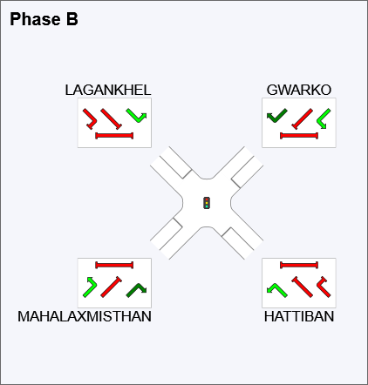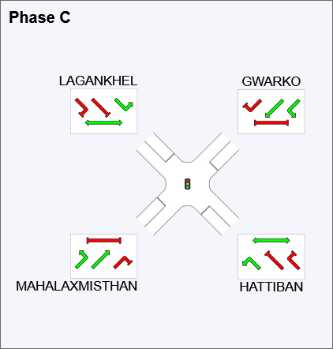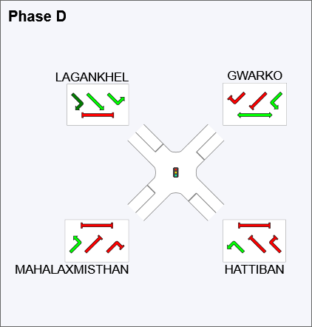
Stopped Movement Normal movement
Permitted/ Opposed Movement

Figure 14: Existing Phase Sequence

3.5.5 Classified Vehicle Count & PCU

The PCU factor for different vehicle is classified as shown in Table 2:
Vehicle classification | PCU/veh.
Heavy truck | 3
Light truck | 1.5
Bus/Mini bus | 3
Micro bus | 1.5
Car/taxi/van/utility/jeep | 1
Motorbike | 0.5
Tempo | 0.75

Table 3: Passenger Car Unit (Nepal Road Standard 2070)

3.5.6 LOS

LOS | CONTROL DELAY PER VEHICLE (s/veh)
A | Less than or equal to 10
B | Greater than 10-20
C | Greater than 20-35
D | Greater than 35-55
E | Greater than 55-80
F | Greater than 80

Table 4: LOS Criteria for signalized Intersection (HCM 2010)

4. Output Analysis

4.1 System Changes and Result Comparison

4.1.1 Optimum Cycle Allocation (Change l)

Optimization was done over current Practical signal time by replacing phase time and cycle time with the program generated optimum signal time keeping all operation environments unchanged. The signal was optimized for minimizing delay.

4.1.1.1 Optimized Existing Phase Timing (MORNING)
Phase | A | B | C | D
Phase Change Time (sec) | 0 | 83 | 150 | 182
Green Time (sec) | 77 | 61 | 26 | 32
Phase Time (sec) | 83 | 67 | 32 | 38
Phase Split | 38% | 30% | 15% | 17%
Table 5: Optimized Existing Phase Timing (Morning)

Stopped Movement Normal movement
Permitted/ Opposed Movement

Figure 15: Existing Phase (Morning)
All Movement Classes
 | Approaches |  |  |  | Intersection
 | Southeast | Northeast | Northwest | Southwest | Intersection
Delay (Control) | 494.1 | 401.8 | 445.9 | 365.6 | 435.2
LOS | F | F | F | F | F

Table 6: Existing Control Delay (Morning)

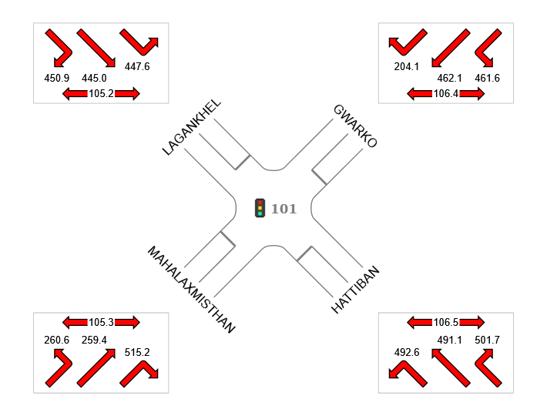

Colour code based on Level of Service
LOS A | LOS B | LOS C | LOS D | LOS E | LOS F
Site Level of Service (LOS) Method: Delay (SIDRA). Site LOS Method is specified in the Parameter Settings dialog (Site tab).
Figure 16: Existing Phase Control Delay (Morning)

4.1.1.2 Design Phase Timing (Morning)

Phase | A | B | C | D
Phase Change Time (sec) | 0 | 77 | 115 | 155
Green Time (sec) | 71 | 32 | 34 | 59
Phase Time (sec) | 77 | 38 | 40 | 65
Phase Split | 35% | 17% | 18% | 30%

Table 7: Design Phase Timing (Morning)

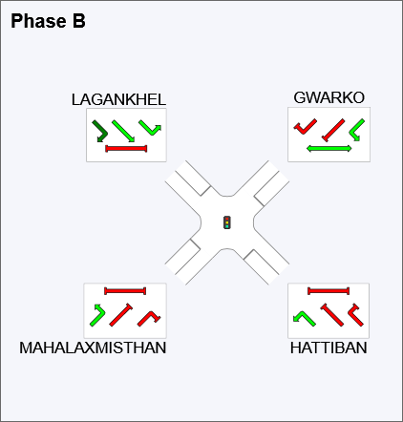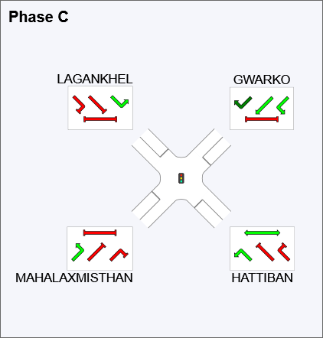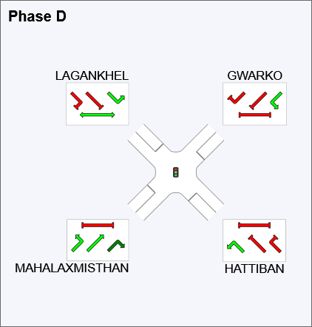
Figure 17: Design Phase (Morning)

All Movement Classes

 | Approaches |  |  |  | Intersection
 | Southeast | Northeast | Northwest | Southwest | Intersection
Delay (Control) | 563.7 | 350.2 | 447.8 | 286.7 | 431.3
LOS | F | F | F | F | F

Table 8: Design Phase Control Delay (Morning)
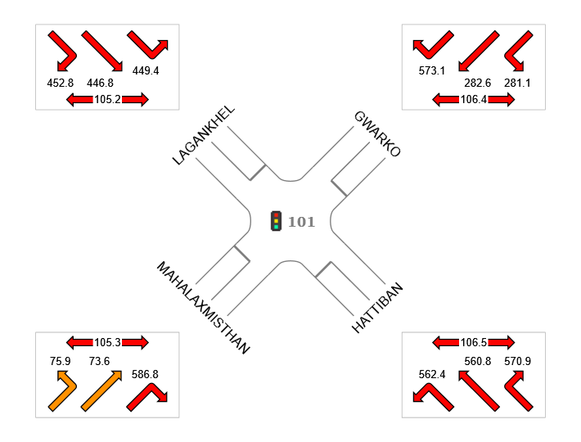

Colour code based on Level of Service
LOS A | LOS B | LOS C | LOS D | LOS E | LOS F

Figure 18: Design Phase Control Delay (Morning)

4.1.2 Comparison of Existing Phase and Design Phase (Morning)

Existing Phase | Approaches |  |  |  | Intersection
Existing Phase | Southeast | Northeast | Northwest | Southwest | Intersection
Delay (Control) | 494.1 | 401.8 | 445.9 | 365.6 | 435.2
LOS | F | F | F | F | F
Design Phase | Approaches |  |  |  | Intersection
Design Phase | Southeast | Northeast | Northwest | Southwest | Intersection
Delay (Control) | 563.7 | 350.2 | 447.8 | 286.7 | 431.3
LOS | F | F | F | F | F
% Decrease Delay | -14.09 | 12.84 | -0.43 | 21.58 | 0.90

Table 9: Comparison of Existing and Design Phase (Morning)

It is clearly visible that, except for south approach there is decrease in delay incase of all other approaches resulting in the overall decrease in delay of the intersection by 3.9 second per vehicle i.e., 0.9%. So, the design phase seems to have more optimized phase timing in comparison to the optimized existing phase timing.

4.1.3 Optimized Existing Phase Timing (EVENING)

Phase | A | B | C | D
Phase Change Time (sec) | 0 | 45 | 93 | 143
Green Time (sec) | 39 | 42 | 44 | 31
Phase Time (sec) | 45 | 48 | 50 | 37
Phase Split | 25% | 27% | 28% | 21%
Table 10: Optimized Existing Phase Timing (Evening)
Stopped Movement Normal movement
Permitted/ Opposed Movement

Figure 19: Existing Phase (Evening)

All Movement Classes
 | Approaches |  |  |  | Intersection
 | Southeast | Northeast | Northwest | Southwest | Intersection
Delay (Control) | 651.5 | 91.6 | 398.4 | 307.0 | 368.9
LOS | F | F | F | F | F

Table 11: Existing Phase Control Delay (Evening)

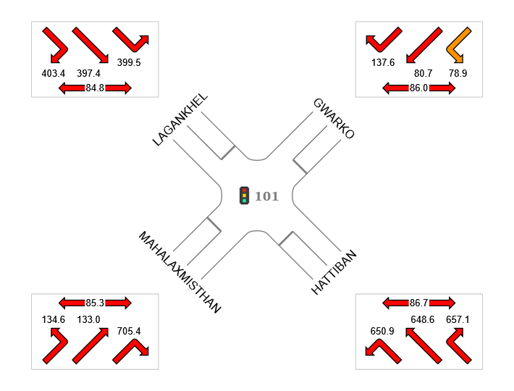

Colour code based on Level of Service
LOS A | LOS B | LOS C | LOS D | LOS E | LOS F

Figure 20: Control Delay (Evening)

4.1.3.1 Design Phase Timing (Evening)

Phase | A | B | C | D
Phase Change Time (sec) | 0 | 61 | 99 | 131
Green Time (sec) | 55 | 32 | 26 | 63
Phase Time (sec) | 61 | 38 | 32 | 69
Phase Split | 31% | 19% | 16% | 35%

Table 12: Design Phase Timing (Evening)

Stopped Movement Normal movement
Permitted/ Opposed Movement

Figure 21: Design Phase (Evening)

All Movement Classes
 | Approaches |  |  |  | Intersection
 | Southeast | Northeast | Northwest | Southwest | Intersection
Delay (Control) | 460.0 | 373.3 | 463.6 | 198.9 | 353.2
LOS | F | F | F | F | F

Table 13: Design Phase Control Delay (Evening)

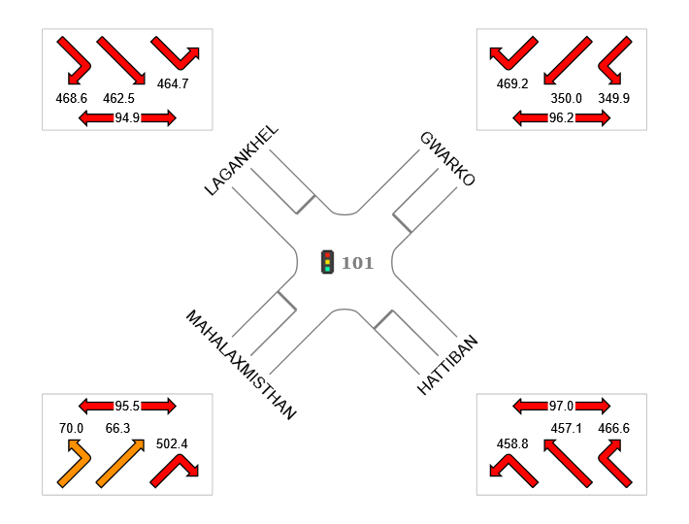

Color code based on Level of Service
LOS A | LOS B | LOS C | LOS D | LOS E | LOS F

Figure 22: Design Phase Control Delay (Evening)

4.1.4 Comparison of Existing phase and Design Phase (Evening)
Existing Phase | Approaches |  |  |  | Intersection
Existing Phase | Southeast | Northeast | Northwest | Southwest | Intersection
Delay (Control) | 651.5 | 91.6 | 398.4 | 307 | 368.9
LOS | F | F | F | F | F
Design Phase | Approaches |  |  |  | Intersection
Design Phase | Southeast | Northeast | Northwest | Southwest | Intersection
Delay (Control) | 460 | 373.3 | 463.6 | 198.9 | 353.2
LOS | F | F | F | F | F
% Decrease Delay | 29.39 | -307.53 | -16.37 | 35.21 | 4.26

Table 14: Comparison of Existing and Design Phase (Evening)

It is clearly visible that, expect for the East approach there is decrease in delay incase of all other approaches resulting in the overall decrease in delay of intersection by 15.7 second per vehicle i.e., 4.26%. So, the design phase seems to have more optimized phase timing in comparison to the optimized existing phase timing.

4.2 Left Turn Controlled Movement with Optimum Cycle (Change ll)

The model was run by changing the free left turn movement to signal controlled movement. To accommodate the added movement required phase sequence changes were made and the model was run for an optimum signal time.

4.2.1 Design Phase Left Turn Controlled (Morning)

Phase | A | B | C | D
Phase Change Time (sec) | 0 | 76 | 113 | 147
Green Time (sec) | 70 | 31 | 28 | 37
Phase Time (sec) | 76 | 37 | 34 | 43
Phase Split | 40% | 19% | 18% | 23%

Table 15: Design Phase LC Timing (Morning)

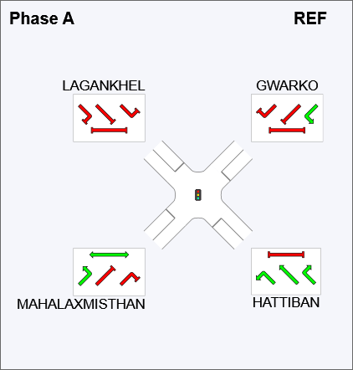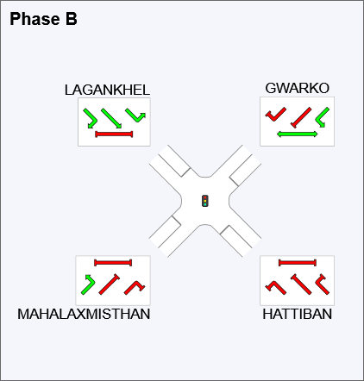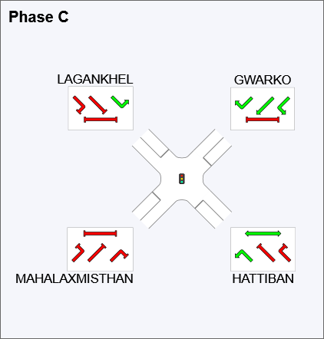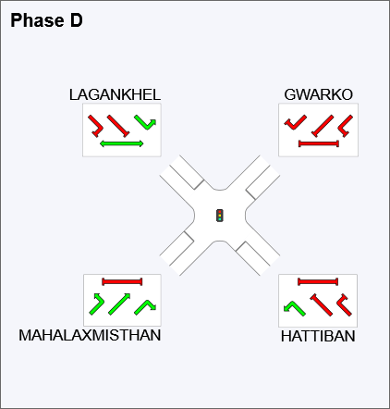

Stopped Movement Normal movement
Permitted/ Opposed Movement

Figure 23: Design Phase LC (Morning)

All Movement Classes
 | Approaches |  |  |  | Intersection
 | Southeast | Northeast | Northwest | Southwest | Intersection
Delay (Control) | 296.4 | 297.9 | 307.5 | 176.6 | 271.4
LOS | F | F | F | F | F

Table 16: Design Phase LC control Delay (Morning)

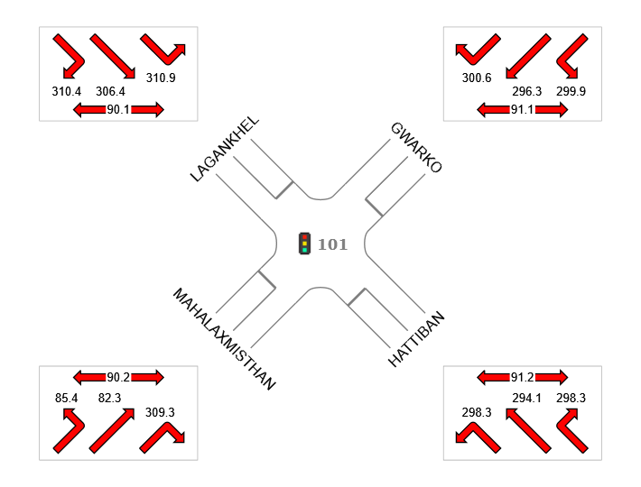

Colour code based on Level of Service
LOS A | LOS B | LOS C | LOS D | LOS E | LOS F

Figure 24: Design Phase LC Control Delay (Morning)

4.2.2 Comparison of Design Phase and LC Design Phase (Morning)

Design Phase | Approaches |  |  |  | Intersection
Design Phase | Southeast | Northeast | Northwest | Southwest | Intersection
Delay (Control) | 563.7 | 350.2 | 447.8 | 286.7 | 431.3
LOS | F | F | F | F | F
Design Phase LC | Approaches |  |  |  | Intersection
Design Phase LC | Southeast | Northeast | Northwest | Southwest | Intersection
Delay (Control) | 296.4 | 297.9 | 307.5 | 176.6 | 271.4
LOS | F | F | F | F | F
% Decrease | 47.42 | 14.93 | 31.33 | 38.40 | 37.07

Table 17: Comparison of Design Phase and LC Design Phase (Morning)

The LOS in both phase remains same as F. While the average delay decreases by 37.07% after incorporating left turn movement under signal control.

4.3 Design Phase Left Turn Controlled (Evening)

Phase | A | B | C | D
Phase Change Time (sec) | 0 | 67 | 114 | 149
Green Time (sec) | 61 | 41 | 29 | 45
Phase Time (sec) | 67 | 47 | 35 | 51
Phase Split | 34% | 24% | 18% | 26%

Table 18: Design Phase LC Timing (Evening)

Stopped Movement Normal movement
Permitted/ Opposed Movement

Figure 25: Design Phase LC (Evening)

All Movement Classes
 | Approaches |  |  |  | Intersection
 | Southeast | Northeast | Northwest | Southwest | Intersection
Delay (Control) | 266.3 | 256.8 | 261.8 | 187.4 | 236.7
LOS | F | F | F | F | F

Table 19: Design Phase LC Control Delay (Evening)

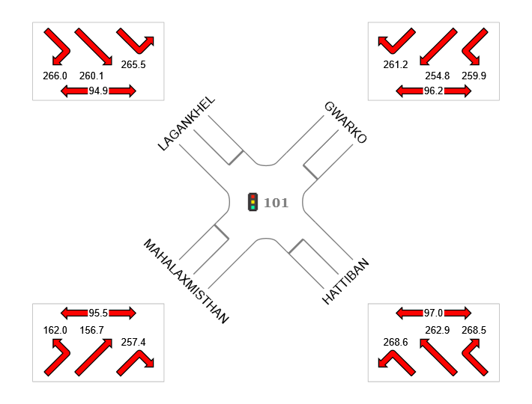

Colour code based on Level of Service
LOS A | LOS B | LOS C | LOS D | LOS E | LOS F

Figure 26: Design Phase LC Control Delay (Evening)

4.4 Comparison of Design Phase and LC Design Phase (Evening)

Design Phase | Approaches |  |  |  | Intersection
Design Phase | Southeast | Northeast | Northwest | Southwest | Intersection
Delay (Control) | 460 | 373.3 | 463.6 | 198.9 | 353.2
LOS | F | F | F | F | F
Design Phase LC | Approaches |  |  |  | Intersection
Design Phase LC | Southeast | Northeast | Northwest | Southwest | Intersection
Delay (Control) | 266.3 | 256.8 | 261.8 | 187.4 | 236.7
LOS | F | F | F | F | F
% Decrease | 42.11 | 31.21 | 43.53 | 5.78 | 32.98

Table 20: Comparison of Design Phase and LC Design Phase (Evening)

The LOS in both phase remains same as F. While the average delay decreases by 32.98% after incorporating left turn movement under signal control.

5. Conclusion and Recommendation

5.1 Conclusion

The analysis reveals that the intersection experiences severe, operating in an oversaturated condition. High traffic volumes exceeding the capacity of all four approaches contribute to persistent queuing and excessive delays. As a result, the current Level of Service (LOS) is rated F, indicating the worst possible traffic flow conditions.
While our proposed design shows only a marginal reduction in overall delay, the most significant improvements are observed in controlled left-turn movements. Although signal time optimization alone does not improve the LOS, it effectively reduces average delay. In particular, implementing dedicated left-turn phases led to a delay reduction of over 30%, demonstrating its potential to enhance intersection efficiency. Therefore, prioritizing controlled left-turn movements in signal design is essential for optimizing traffic flow and minimizing delays at the intersection.

5.2 Recommendation

Despite implementing mitigation measures such as increasing cycle length and reallocating splits, the simulation results showed minimal improvements in saturation levels and delays across most lanes. Therefore, adopting an adaptive control system that utilizes vehicle detection data and real-time algorithms is recommended. This system dynamically adjusts green, yellow, and red signal timings to better accommodate fluctuating traffic patterns. Additionally, promoting public transportation can help reduce vehicle dependency and ease congestion. Regular performance monitoring and future studies should be conducted to assess intersection efficiency and make necessary adjustments for continuous improvement.

6. References

- Dhakal K, Tiwari H, Luitel S. Evaluation and Performance Enhancement of four Legged Intersection: Satdobato, Nepal. J Adv Res Const Urban Arch. 2023; 8(1): 23-30

- S. Shrestha and A. Marsini, “Development of Saturation Flow and Delay Model at Signalised Intersection of Kathmandu.”

- SIDRA Solutions. (2020). SIDRA Intersection 8: Guidelines and Documentation. SIDRA Solutions. Retrieved from https://www.sidrasolutions.com

- National Research Council (U.S.). Transportation Research Board., HCM 2010 : highway capacity manual. Transportation Research Board. 2010.

- Asian Development Bank (ADB). (2019). Assessing the Impact of Traffic Congestion on the Economy in Kathmandu, Nepal. Asian Development Bank. Retrieved from https://www.adb.org

- Rathi, S., & Ghosh, S. (2015). "Delay Estimation and Level of Service for Mixed Traffic Conditions: A Case Study of India." Transportation Research Part A: Policy and Practice, 78, 161-175.
This study proposes delay estimation models for mixed traffic conditions and suggests methodologies for assessing congestion and LOS.

- RB Bista S. Paneru RB. Bista and S. Paneru, “Does Road Traffic Congestion Increase Fuel Consumption of Households in Kathmandu City?,” Journal of Economic Impact. 2021;3(2):67-79. doi: 10.52223/JEI3022102.

- National Research Council (U.S.). Transportation Research Board., Highway capacity manual : a guide for multimodal mobility analysis.

- “Webster FV. and Cobbe, B. (1966) Traffic Signals. Road Research Technical Papers. - References - Scientific Research Publishing.” https://www.scirp. org/(S(351jmbntv-nsjt1aadkposzje))/reference/ referencespapers.aspx?referenceid=1962597 (accessed Mar. 13, 2023).

- MJ Mahapatra M. Advani and AU Ravi Shakar, “Estimation and Comparison of Saturation Flow at Signalized Intersection in Mixed Traffic Condition,” in Proceedings of the Fifth International Conference of Transportation Research Group of India, Akhilesh Kumar Maurya; Bhargab Maitra; Rajat Rastogi Animesh Das, Ed., Fifth.India: Springer. 2019;1-13. doi: 10.1007/978 981-16-8259-9.

- P Ranjitkar A, Shahin and F Shirwali, “Evaluating Operational Performance of Intersections Using SIDRA. 2014.

- R Akçelik and M. Besley, “Microsimulation and analytical methods for modelling urban traffic. 2001. [Online]. Available: www.aatraffic.com

- . C Tianzi J. Shaochen and Y. Hongxu, “Comparative Study of VISSIM and SIDRA on Signalized Intersection,” Procedia Soc Behav Sci. 2013;96:2004-2010. doi: 10.1016/j.sbspro.2013.08.226.

- TV Mathew and P Radhakrishnan, “Calibration of Microsimulation Models for Nonlane-Based Heterogeneous Traffic at Signalized Intersections”, doi: 10.1061/ASCE0733-94882010136:159.

APPENDIX

